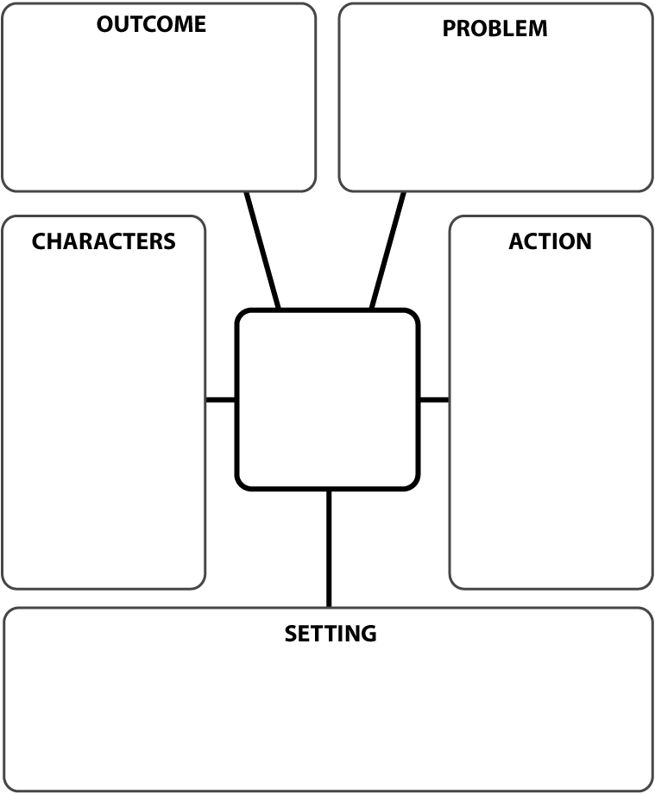

<http://blog.janicehardy.com/2012/08/the-inner-struggle-guides-for-using.html>

**A past wound or hurt that is a current unhealed source of pain.**

**What the character believes due to the wound. How it shapes her worldview.**

**What terrifies the character emotionally; some version of experiencing that wound pain again.**

**The false self the character presents to the world. The emotional armor that protects from the fear, created by the belief, that came from the wound.**

**What lies under all the emotional armor. The real self. Here’s the finish line for that character arc.**

**The thing the character longs for (desires) or needs (something missing) in the story.**

INNER STRUGGLE

WOUND

BELIEF

FEAR

IDENTITY

ESSENCE

LONGING OR NEED